Insert your name, centre number and candidate number into the header above.
Save this evidence document as evidence_ followed by your centre number_ candidate number, for example: evidence_ zz999_9999.doc
Screenshots or program listings must be copied into appropriate cells in the following tables.
Examiners must be able to read the contents including any screenshots without the use of a magnifying glass. Answers that are not readable or are missing will not be awarded any marks.
Save this evidence document at regular intervals, for example, every 10 minutes.
Question 1
Part 1(a)
global DataArray
DataArray = [0 for I in range(100)]

Part 1(b)
def ReadFile():
global DataArray
try:
TextFile = "IntegerData.txt"
File = open(TextFile, 'r')
for X in range(0,100):
DataArray[X] = File.readline()
DataArray[X].rstrip('\n')
DataArray[X] = int(DataArray[X])
File.close()
except IOError:
print("Could not find file")

Part 1(c)
def FindValues():
global DataArray
DataToFind = -1
while (DataToFind < 1 or DataToFind > 100):
DataToFind = int(input("Enter a number between 1 and 100 "))
Total = 0
for X in range(0,100):
if DataArray[X] == DataToFind:
Total = Total + 1
return Total

Part 1(d)(i)
ReadFile()
print("The number appears " + str(FindValues()) + " times")

Part 1(d)(ii)
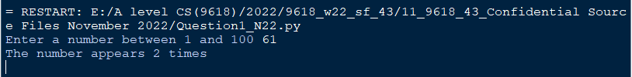

Part 1(e)
#main
ReadFile()
print("The number appears " + str(FindValues()) + " times")
BubbleSort()

Question 2
Part 2(a)(i)
class Card:
#Number as integer
#Colour as string
def __init__(self, Number1, Colour1):
self.__Number = Number1
self.__Colour = Colour1

Part 2(a)(ii)
def GetNumber(self):
return self.__Number
def GetColour(self):
return self.__Colour

Part 2(a)(iii)
OneRed = Card(1, "red")
TwoRed = Card(2, "red")
ThreeRed = Card(3, "red")
FourRed = Card(4, "red")
FiveRed = Card(5, "red")

OneBlue = Card(1, "blue")
TwoBlue = Card(2, "blue")
ThreeBlue = Card(3, "blue")
FourBlue = Card(4, "blue")
FiveBlue = Card(5, "blue")

OneYellow = Card(1, "yellow")
TwoYellow = Card(2, "yellow")
ThreeYellow = Card(3, "yellow")
FourYellow = Card(4, "yellow")
FiveYellow = Card(5, "yellow")

Part 2(b)(i)
class Hand:
#Cards[10] as Card
#FirstCard as integer
#NumberCards as integer
def __init__(self, Card1, Card2, Card3, Card4, Card5):
self.__Cards = []
self.__Cards.append(Card1)
self.__Cards.append(Card2)
self.__Cards.append(Card3)
self.__Cards.append(Card4)
self.__Cards.append(Card5)
self.__FirstCard = 0
self.__NumberCards = 5

Part 2(b)(ii)
def GetCard(self, Position):
return self.__Cards[Position]

Part 2(b)(iii)
Player1 = Hand(OneRed, TwoRed, ThreeRed, FourRed, OneYellow)
Player2 = Hand(TwoYellow, ThreeYellow, FourYellow, FiveYellow, OneBlue)

Part 2(c)(i)
def CalculateValue(Player):
Score = 0
for Count in range(0,5):
CardGot = Player.GetCard(Count)
Score = Score + CardGot.GetNumber()
Colour = CardGot.GetColour()
if Colour == "red":
Score = Score + 5
elif Colour == "blue":
Score = Score + 10
else:
Score = Score + 15
return Score

Part 2(c)(ii)
Player1score = CalculateValue(Player1)
Player2score = CalculateValue(Player2)
if Player1score > Player2score:
print("Player 1 wins")
elif Player1score < Player2score:
print("Player 2 wins")
else:
print("It's a draw")

Part 2(c)(iii)
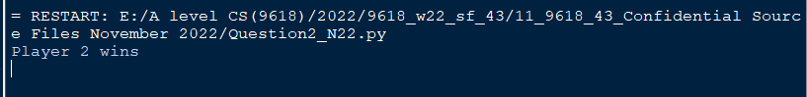

Question 3
Part 3(a)
global ArrayNodes
ArrayNodes = []
for x in range(0,20):
ArrayNodes.append([-1,-1,-1])

Part 3(b)
ArrayNodes = [[1,20,5],[2,15,-1],[-1,3,3],[-1,9,4],[-1,10,-1],[-1,58,-1],[-1,-1,-1]]
FreeNode = 6
RootPointer = 0

Part 3(c)
def SearchValue(Root, ValueToFind):
global ArrayNodes
if Root == -1:
return -1
elif ArrayNodes[Root][1] == ValueToFind:
return Root
elif ArrayNodes[Root][1] == -1:
return -1
if (ArrayNodes[Root][1] > ValueToFind):
return SearchValue(ArrayNodes[Root][0], ValueToFind)
if (ArrayNodes[Root][1] < ValueToFind):
return SearchValue(ArrayNodes[Root][2], ValueToFind)

Part 3(d)
def PostOrder(RootNode):
global ArrayNodes
if RootNode[0] != -1:
PostOrder(ArrayNodes[RootNode[0]])
if RootNode[2] != -1:
PostOrder(ArrayNodes[RootNode[2]])
print(str([RootNode[1]))

Part 3(e)(i)
ReturnValue = SearchValue(RootPointer, 15)
if ReturnValue == -1:
print("Not found")
else:
print("Found at " + str(ReturnValue))
PostOrder(ArrayNodes[RootPointer])

Part 3(e)(ii)
